LICHEN SCLEROSUS

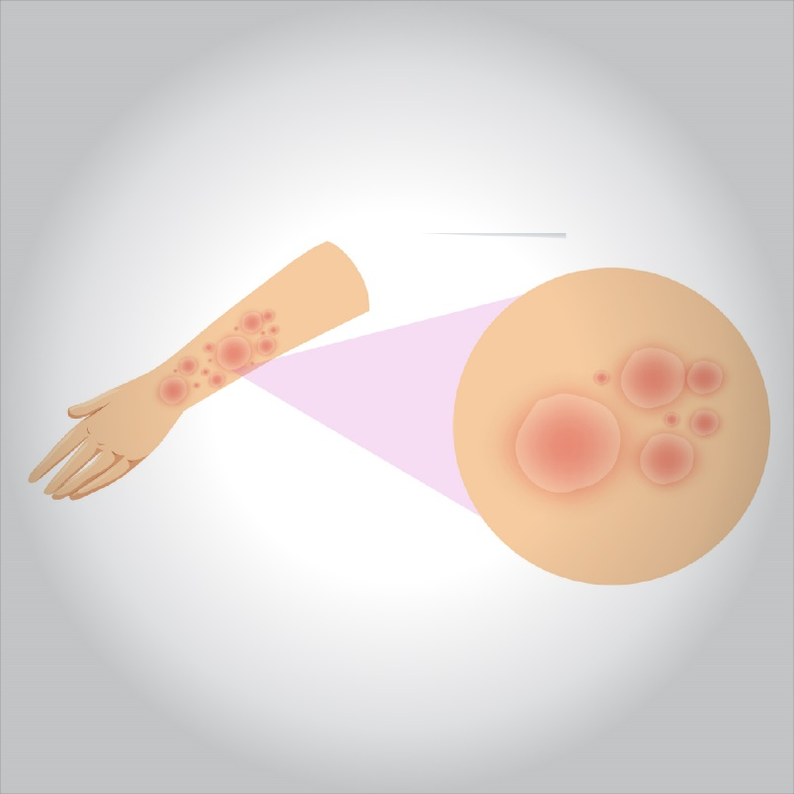

**Lichen sclerosus is an uncommon condition that creates patchy, white skin that appears thinner than normal. It usually affects the genital and anal areas.**

**Anyone can get lichen sclerosus but postmenopausal women are at higher risk.**

**Your doctor can suggest treatment with creams or ointments that help return a more normal appearance to your skin and decrease the tendency for scarring. The condition does tend to recur, so long-term follow-up care may be needed. Rarely, lichen sclerosus improves without treatment.**

**What are the symptoms?**

**People with mild lichen sclerosus may have no signs or symptoms.**

**Signs and symptoms usually affect the skin of the genital and anal areas, but may also affect the skin of the upper body, upper arms and breasts. They may include:**

* **Redness**
* **Itching (pruritus), which can be severe**
* **Discomfort or pain**
* **Smooth white patches on your skin**
* **Blotchy, wrinkled patches**
* **Tearing or bleeding**
* **In severe cases, bleeding, blistering or ulcerated sores**
* **Painful sex**

**When to see a doctor**

**See your doctor if you have signs and symptoms common to lichen sclerosus.**

**If you’ve already been diagnosed with lichen sclerosus, see your doctor every six to 12 months to be checked for any skin changes or treatment side effects.**

**What are the causes?**

**The cause of lichen sclerosus is unknown. An overactive immune system or an imbalance of hormones may play a role. Previous skin damage at a particular site on your skin may increase the likelihood of lichen sclerosus at that location.**

**Lichen sclerosus isn’t contagious and cannot be spread through sexual intercourse.**

**Lichen sclerosus often occurs in postmenopausal women, but also in men and children. In women, lichen sclerosus usually involves the vulva. In boys and men, uncircumcised males are most at risk, because the condition generally affects the foreskin.**

**In children, the signs and symptoms may improve at puberty, but they will still need monitoring for disease activity.**

**Complications**

**Complications of lichen sclerosus include painful sex, urinary retention, constipation and an inability to retract the foreskin. People with lichen sclerosus are also at an increased risk of squamous cell carcinoma of the affected area.**

**What is the diagnosis?**

**Your doctor may diagnose lichen sclerosus based on:**

* **A physical examination**
* **Removal of a small piece of affected tissue (biopsy) for examination under a microscope**

**Your doctor may refer you to a specialist in skin conditions (dermatologist) or the female reproductive system.**

**Treatment**

**If you have lichen sclerosus on or around your genitals or anus, or have a more advanced case on other parts of your body, your doctor will recommend treatment. Treatment helps reduce itching, improve your skin’s appearance and decrease further scarring. Recurrence is common. Rarely, lichen sclerosus gets better on its own.**

**Corticosteroids**

**Corticosteroid ointments or creams are commonly prescribed for lichen sclerosus. Initially, you’ll generally have to use cortisone creams or ointments on the affected skin twice a day. After several weeks, your doctor will likely recommend that you only use these medications twice a week to prevent a recurrence.**

**Your doctor will monitor you for side effects associated with prolonged use of topical corticosteroids, such as further thinning of the skin.**

**Other treatment options**

**If corticosteroid treatment doesn’t work or if months of corticosteroid therapy are needed, your doctor may prescribe an ointment such as tacrolimus (Protopic).**

**Removal of the foreskin (circumcision) in men is a common treatment in cases resistant to other therapies or more-advanced cases. Surgery in the genital or anal area generally isn’t recommended for women with lichen sclerosus because the condition may just come back after surgery.**

**Ask your doctor how often you should return for follow-up exams. They are generally recommended every six to 12 months.**

**Lifestyle and home remedies**

**These self-care tips may help, whether you are undergoing treatment or not:**

* **Apply lubricant (petroleum jelly, A and D ointment, Aquaphor) to the affected area.**
* **Gently wash the affected area daily and pat dry. Avoid harsh soaps and bathing too much.**
* **Ease burning and pain with oatmeal solutions, sitz baths, ice packs or cool compresses.**
* **Take an oral antihistamine at bedtime to help control the itching as you try to sleep.**